Steps for submission of Bank Guarantee in iTUFS under ATUFS – reg.
Step 1:Unit to Login to their respective account with User-ID and Password
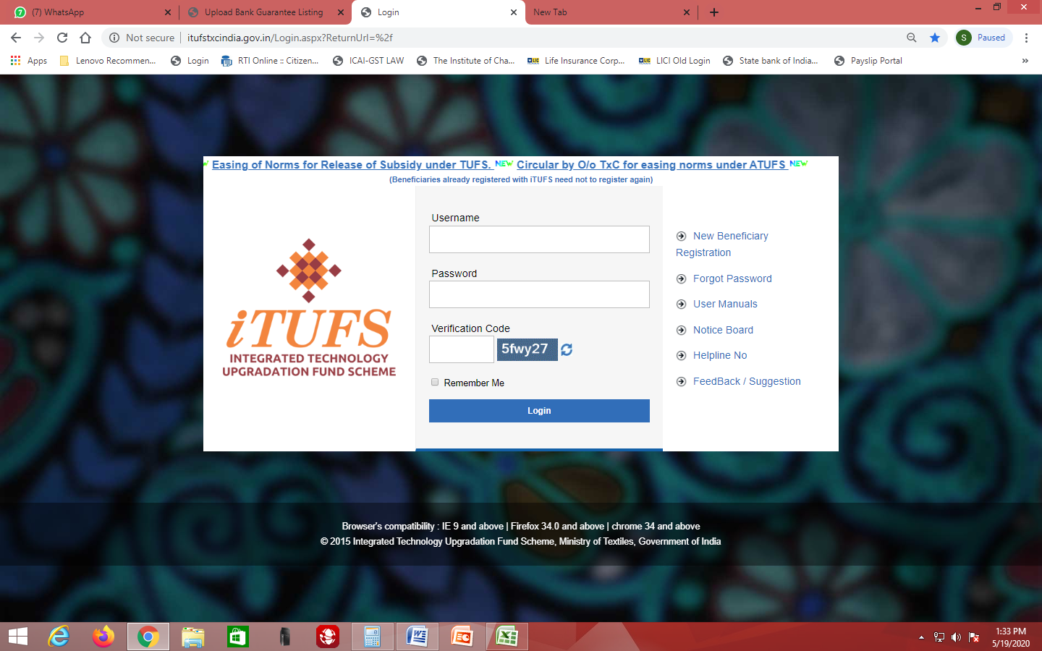
Step 2: Unit will be taken to the following page 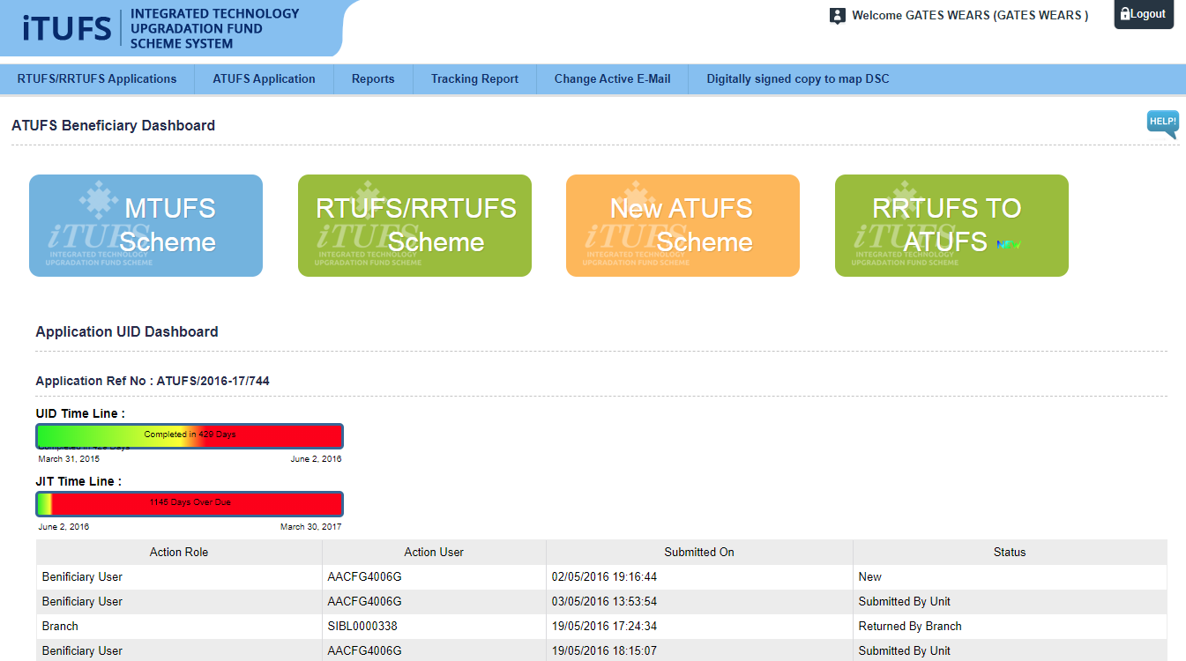

Step 3: Go to ATUFS Application tab and select the Last option “Upload BG (ATufs)”

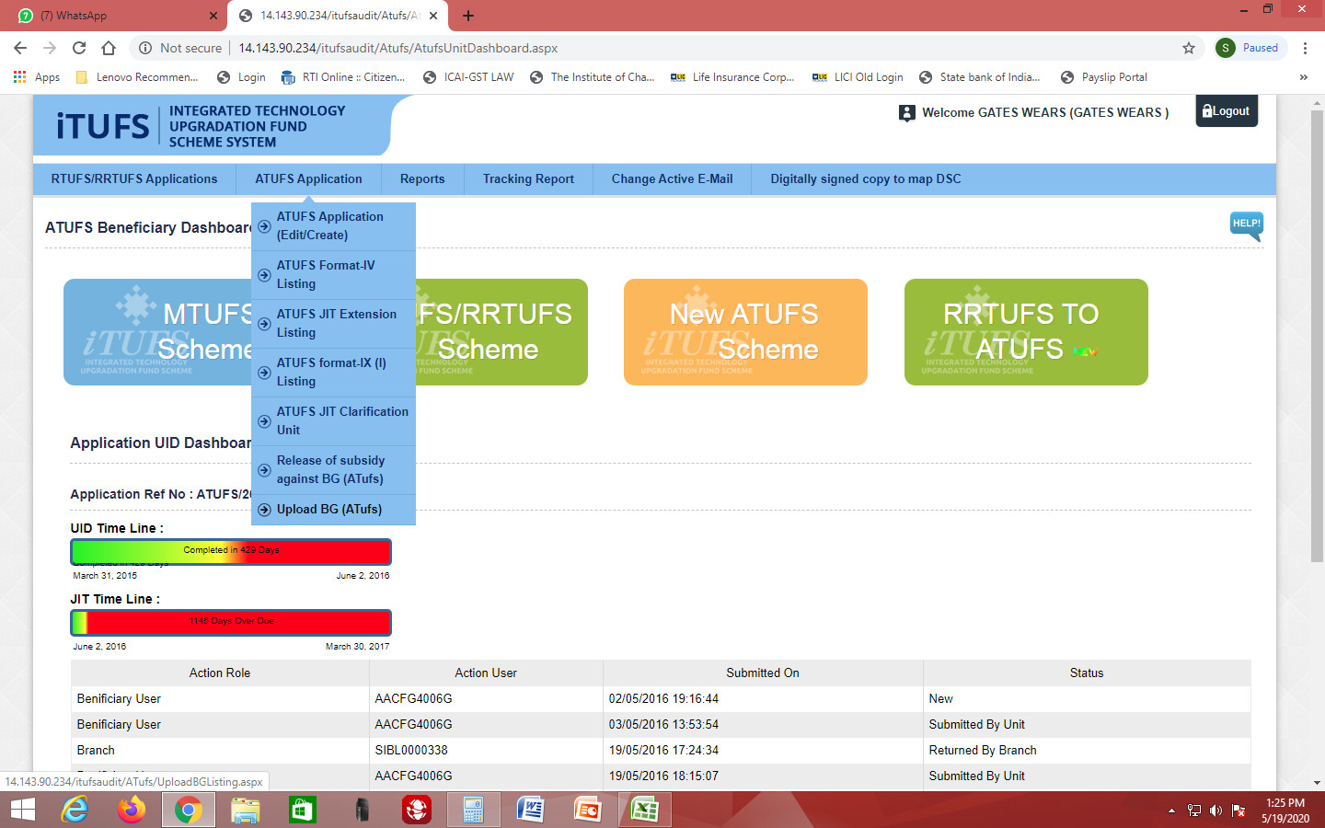

Step 4: On selection, the following page appears. Click on “pencil icon” Edit button to proceed further.
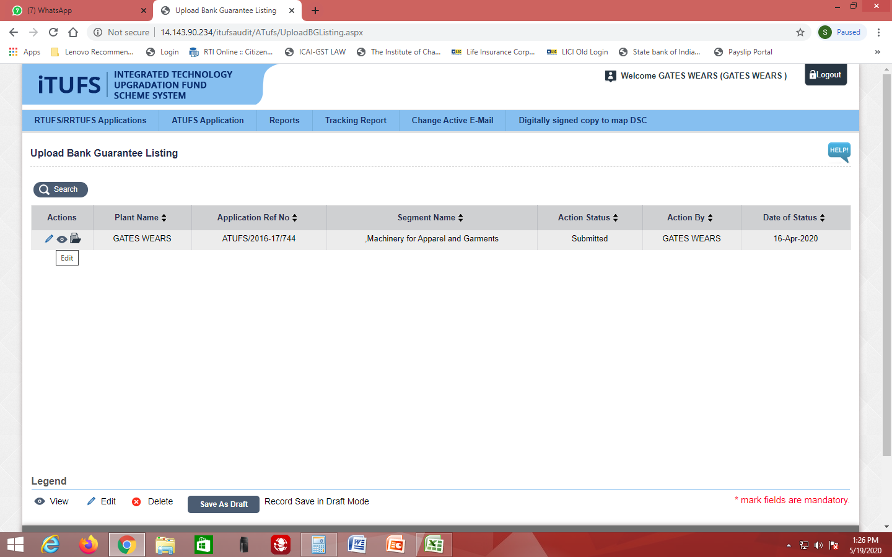

Step 5: The following page will appear for unit to enter information on the Bank Guarantee.

- Select from drop down menu the bank and branch name which has issued BG with details such as date of Issue and date of expiry (with Twelve Month validity), amount (at least 90% of JIT recommended subsidy) and Bank Guarantee number. If the loan has been taken over by another lending agency, BG should be issued by the bank which has taken over the loan. Procedure for takeover as per ATUFS guidelines should be initiated simultaneously.

- In Documentation part, upload soft copy of bank guarantee. If the loan has been sanctioned under Consortium financing, NOC should also be obtained from the member banks and uploaded.

- Enter pre disbursement details, such as Bank mandate form, Agency registration details and pre- receipt (mentioning 80% of JIT recommended amount) duly affixing revenue stamp.
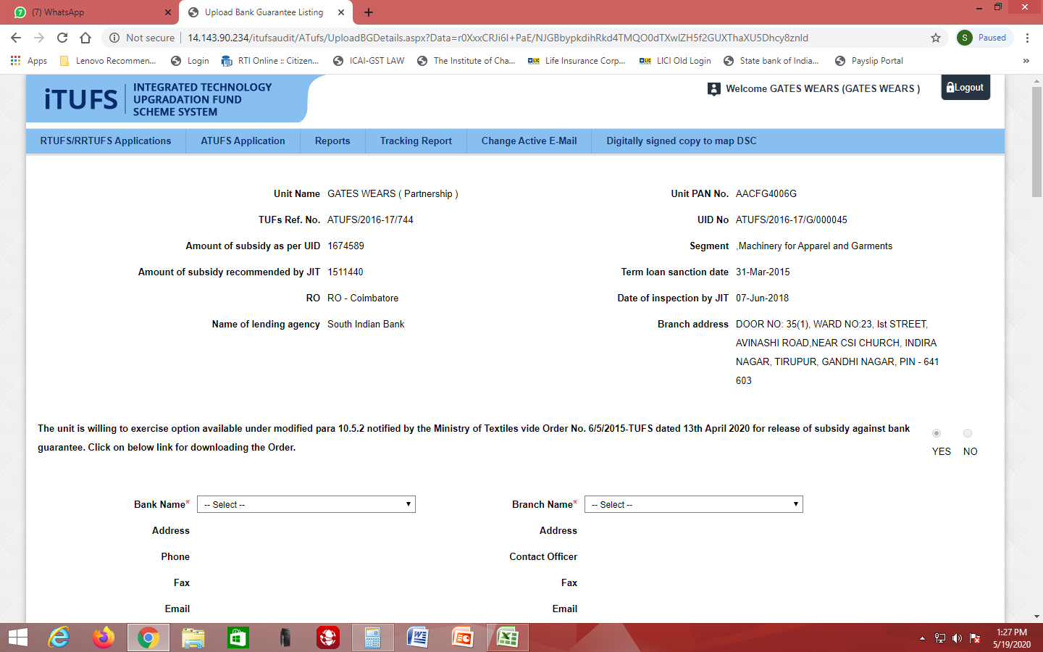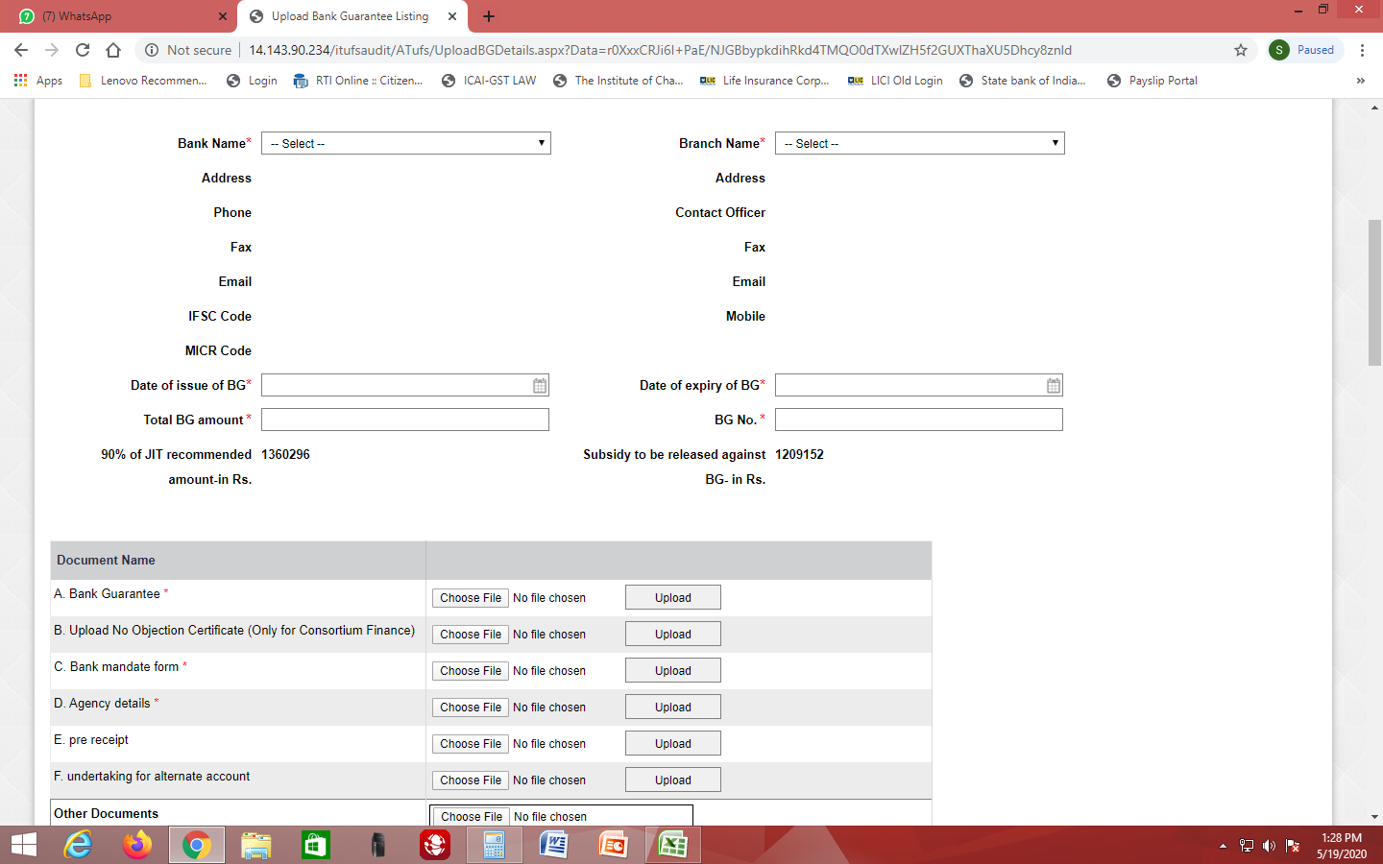

- “Click On” the correct button to declare the current status of enlistment of manufacturer. In case of not knowing the current status, information / Comments under “Remarks” is mandatory. 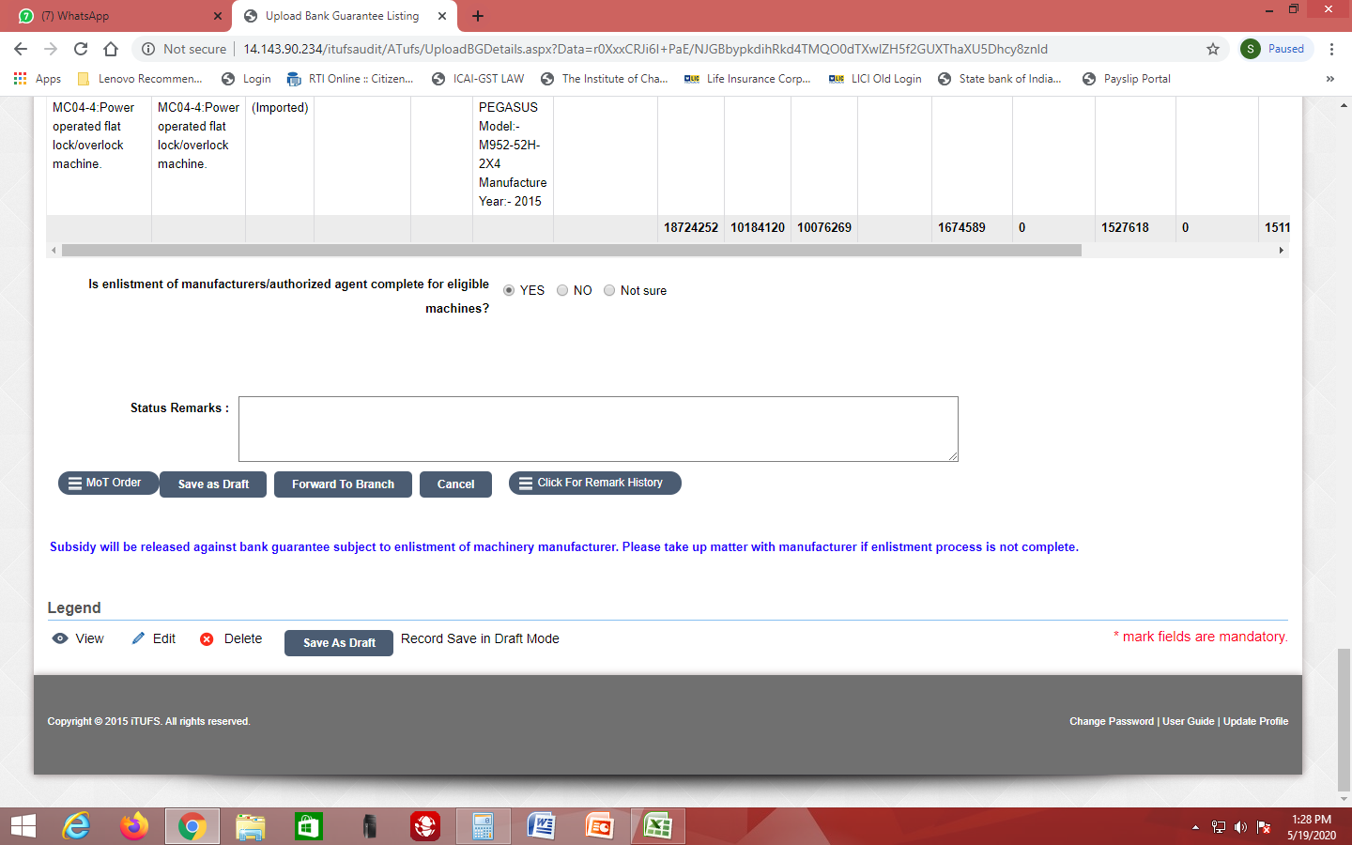

Step 6 : The unit now have two options:
    - Save As draft - To review and submit later on
    - Forward to Branch - This action will lead to submit the application to the `Bank which has issued the BG for confirmation.

    - Re-verify all the details entered above, since this action cannot be undone at later stage.

SOP on procedure for the Banks will follow.

**************

